**MesoFusion Plugin**

Document Prepared by: Ranjan Ramachandra, UCSD and Shefali Krishna, Salk Institute, Rafael Arrojo e Drigo, Vanderbilt University.

.

**Purpose**

The following excerpt is from “*Identification of long-lived proteins in the mitochondria reveals increased stability of the electron transport chain”* Krishna et.al, Developmental Cell 2021 “With MIMS-EM, the correlation and overlay of N15/N14 ratio images atop SEM micrographs has the advantage of displaying the chemical information of the sample while retaining the resolution and ultrastructural detail afforded by the SEM. A SEM image on UCSD’s Zeiss platform can be acquired for a raster size of up to 32k X 32k pixels. In comparison, the raster size on Caltech’s Cameca NanoSIMS can go up to a maximum of only 1024 X 1024 pixels. Beyond differences in scale, the signal collection mechanisms for the two instruments are completely different. When imaging sections in the SEM (to be later interrogated by nano-SIMS), signal collection is non-destructive, while in the NanoSIMS the signals are collected destructively by the sputtering atoms from the sample (Benninghoven, Rudenauer et al. 1987, Goldstein, Newbury et al. 2003). The sputter rates are vastly different for the different atomic species, resulting in a non-linear distortion of the NanoSIMS image with respect to the SEM ultrastructural reference image, complicating the fusion of these datasets. Manual alignment of the two images can insert operator bias into the correlation process. Automated alignment using simple affine transformations is also insufficient given the non-linear nature of the distortions. For proper alignment, the 15N/14N ratio image needs to be automatically adjusted for warping with respect to the SEM image. There are freely available warp adjustment softwares, such as the ‘UnwarpJ’ plugin of ImageJ (Sorzano, Thevenaz et al. 2005, Schneider, Rasband et al. 2012), that adjusts for distortions in one image with respect to the undistorted image. However, the plugin expects that the images be somewhat similar i.e. they are from the same imaging modalities. To facilitate the seamless alignment of the MIMS image to the SEM image, we developed a plugin called **‘MesoFusion’, which stands for Mesoscale Image Fusion.”**

Although, initially intended to align MIMS/NanoSIMS image to SEM image, these set of tools can be used to align any two image of the sample obtained from completely different imaging modalities. The images output from the NanoSIMS instrument (Nanoscale secondary ion mass spectrometry), are referred to as NanoSIMS image or MIMS image (Multi-isotope Imaging Mass Spectrometry). For consistency, we will refer it as MIMS in this document. This ImageJ Plugin is made freely available to the scientific community at large. If you used MesoFusion Plugin, we would really appreciate if you cite the following paper in your publication :-

“*Identification of long-lived proteins in the mitochondria reveals increased stability of the electron transport chain”* Krishna et.al, Developmental Cell.

If you used the ImageJ plugin “UnwarpJ” in conjunction with MesoFusion, we would kindly request you to cite this paper too :-

*"*[*Elastic Registration of Biological Images Using Vector-Spline Regularization*](http://bigwww.epfl.ch/publications/sorzano0501.html)*"* C.Ó. Sánchez Sorzano, P. Thévenaz, M. Unser,  IEEE Transactions on Biomedical Engineering, vol. 52, no. 4, pp. 652-663, April 2005.

For general information about the NanoSIMS instrument and Imaging techniques, please refer to:

*“High-resolution quantitative imaging of mammalian and bacterial cells using stable isotope mass spectrometry”* Lechene et.al, Journal of Biology, vol.5, article 20, 2006.

*“Scanning secondary ion analytical microscopy with parallel detection”* Slodzian, Biol Cell, 74, 43 – 50, 1992.

**Schematic**

MesoFusion

MesoFusion Single

MesoFusion Mosaic

UnwarpJ or other warp correction programs

Colorize Ratio Map

Categorize Ratio Map

Create Layout

Rescale

Resize

Rescale

Resize

Create Layout

Categorize Ratio Map

Colorize Ratio Map

UnwarpJ or other warp correction programs

Assemble Tiles

The Plugin is broadly divided into two broad categories:- MesoFusion Single and MesoFusion Mosaic. The core functionality of both the categories are the same, except that MesoFusion Single aligns single MIMS image to a Single SEM image, and MesoFusion Mosaic aligns and stitches many MIMS images to a single SEM image (usually a large field of view SEM image from ATLAS).

For proper alignment, the MIMS ratio image of interest i.e. 15N/14N (or C13/C12) has to be corrected with reference to the SEM image, for any non-linear distortions. The SEM image is considered to be the original/true image, while the MIMS image which is generated by a destructive process is considered to be the distorted image. Therefore, all non-linear transforms are applied to MIMS images; and only linear transforms like translation, flipping and rotation are applied to the SEM image. The plugin ‘UnwarpJ’ corrects for the distortions in an image with respect to the original (or undistorted) image. However, it expects that the two images be somewhat similar i.e. they are from the same imaging modalities. The initial subroutines of Mesofusion (i.e. Rescale Resize and Create Layout) accessorizes the SEM and MIMS image to make them look similar, and then can be subsequently fed into the UnwarpJ plugin for any correction/alignment. The other subroutines of MesoFusion, provide information on the quantitative spatial signal intensities (Categorize Ratio map) and colorized visual, detailing the chemical signal intensity at a high spatial resolution (Colorize Ratio map).

The NanoSIMS instrument can simultaneously detect/measure 7 different ions, generating 7 MIMS images for every scan. For e.g., it can generate images/maps of 12C, 14N, 15N, 16O, 28Si, 31P, 32S for every scanned region of the sample. The main purpose of using the NanoSIMS instrument in this case will be to generate the nitrogen isotope ratio map i.e. 15N/14N ratio map, which is computed by dividing the 15N image by 14N image, and normalizing it to the naturally occurring 15N to 14N concentration in nature. And it is the 15N/14N ratio map that has to be finally aligned to the SEM image. The MesoFusion plugin, provides option to either directly align the 15N/14N ratio map to the SEM image or align any other MIMS image for e.g, 32S with the SEM image, record all the transformations and finally apply them to the 15N/14N ratio map. The choice of selecting which MIMS image or ratio map to use for the alignment depends on which resembles the SEM image more closely. Ideally, it is recommended to use something other than N15/N14 ratio map (say Sulphur or Phosphorous map) for the alignment with the SEM image, and later apply the transformations to the N15/N14. This will make the alignment a little more authentic so as to say, since you will be avoiding operator bias of intentionally trying to match images of interest.

We will first explain in details how the various subroutines of MesoFusion Single works, and later explain the additional features of MesoFusion Mosaic. Plugin is divided into 5 subroutines :- 1.Rescale\_Resize 2.Create\_Layout 3.Categorize\_Ratio\_Map 4. Colorize\_Ratio\_Map.

The Plugin works sequentially i.e. the output of subroutine “Rescale\_Resize” will be the input for the subroutine “Create\_Layout”, and so forth. The Images that will be presented below are from the Krishna et.al paper.

**MESOFUSION Single** :

* 1. **ReScale and ReSize** :

Purpose: Applies linear transformation (no Warp adjustments) of flipping, rotation and translation to roughly align the MIMS image to the SEM image. It also re-sizes the MIMS image to match the pixel size of the SEM image.

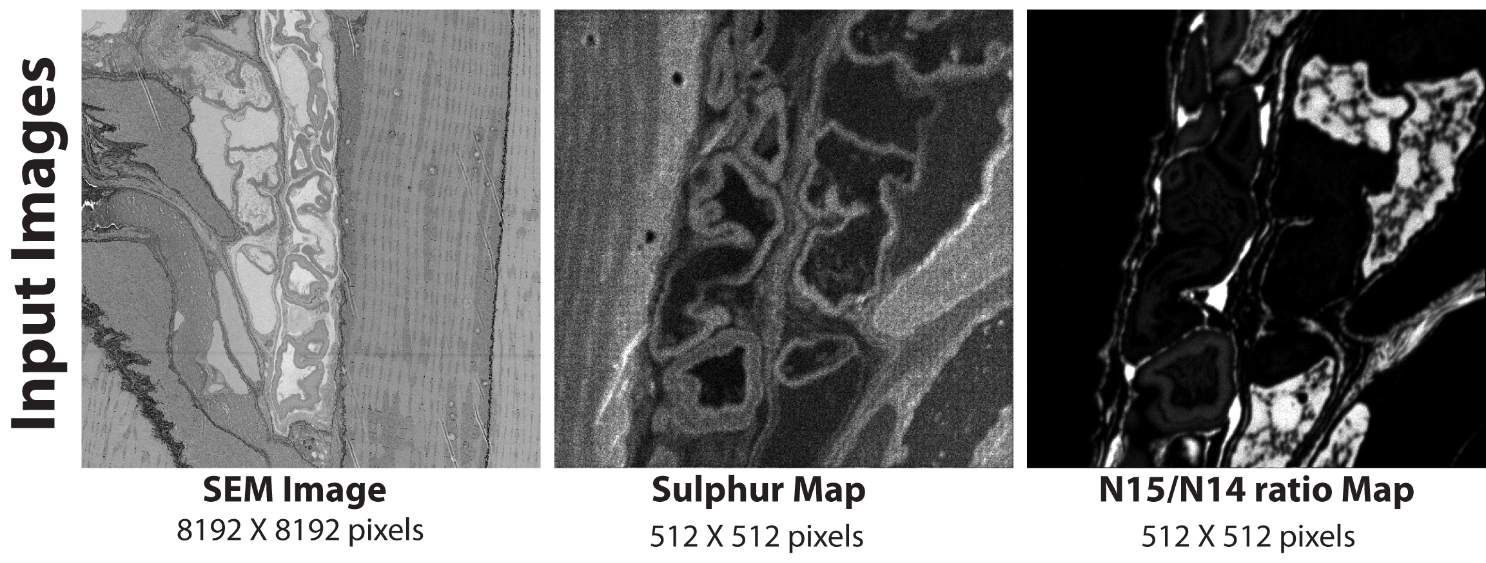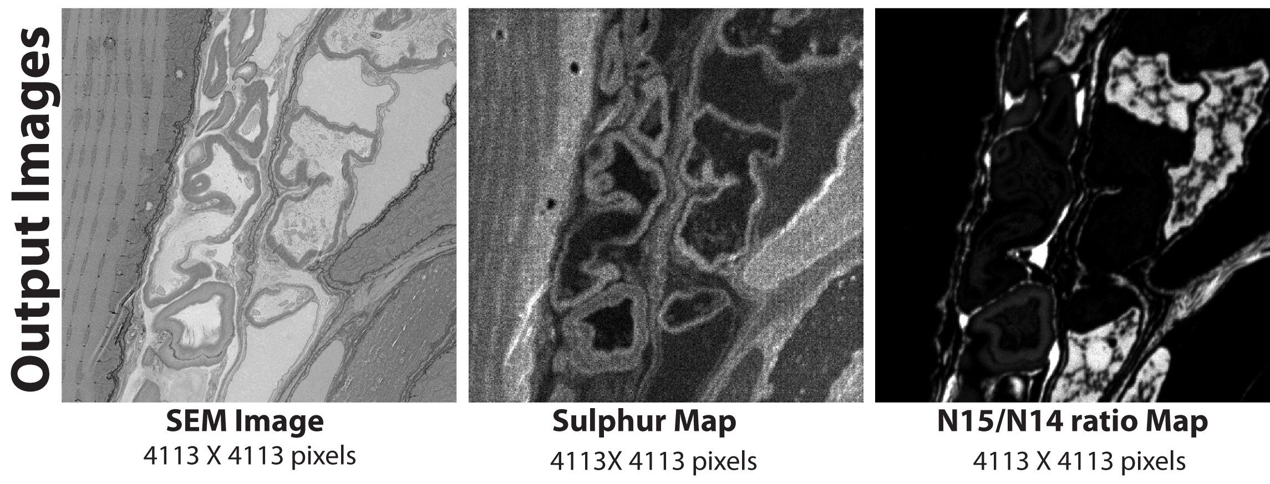

The Plugin will prompt you to find out if you are using the N15/N14 ratio map or an intermediate image like sulpur or 14N map for the alignment, check the box appropriately. The plugin will guide you to open the MIMS and the SEM image, and request you to select two feature points in the MIMS Image (zoom in if required), such that the second point makes an angle approx. between 20 – 70 deg with a horizontal line passing through the first point. Then select the same two feature points in the SEM image, **in the same order**. For best results, choose the two points such that they are as far away as possible from each other. The Plugin will use this information to correct for any image flipping and rotation.

Next, the plugin will ask you to select a rectangular ROI in the MIMS image enclosing a large organelle something like a nucleus, and then prompt you to select the same region in the SEM image. This will correct for any translation adjustments.

Finally, the plugin may prompt you to select a rectangular ROI in the SEM image to get rid of discrepancies at the edge. The meaning of discrepancies at the edge, is that due to any of the linear transformations, there may be strips at the edges that are black i.e. 0 intensity. So select the ROI so as to avoid the black strips, if there are no black strips in the image then select the entire image.

If, you used an image other than the N15/N14 (or C13/C12) ratio map for alignment, the plugin will ask you to open the N15/N14 (or C13/C12) ratio map so that it can apply these transforms to that image too.

The subroutine will create a subfolder called “ScaledXX”, where XX is the index (1,2,3 etc..), and saves all the output files in this folder with a suffix “SCALED”.

* 1. **Create Layout :**

Purpose:This plugin skeletonizes the MIMS and SEM image, previously aligned in the “ReScale and ReSize” subroutine to create the so-called “Barebones” image, so that they both now look somewhat similar. Once you have the Barebones image, they can be fed to the UnwarpJ program to correct for any Warping in the MIMS image with reference to the SEM image.

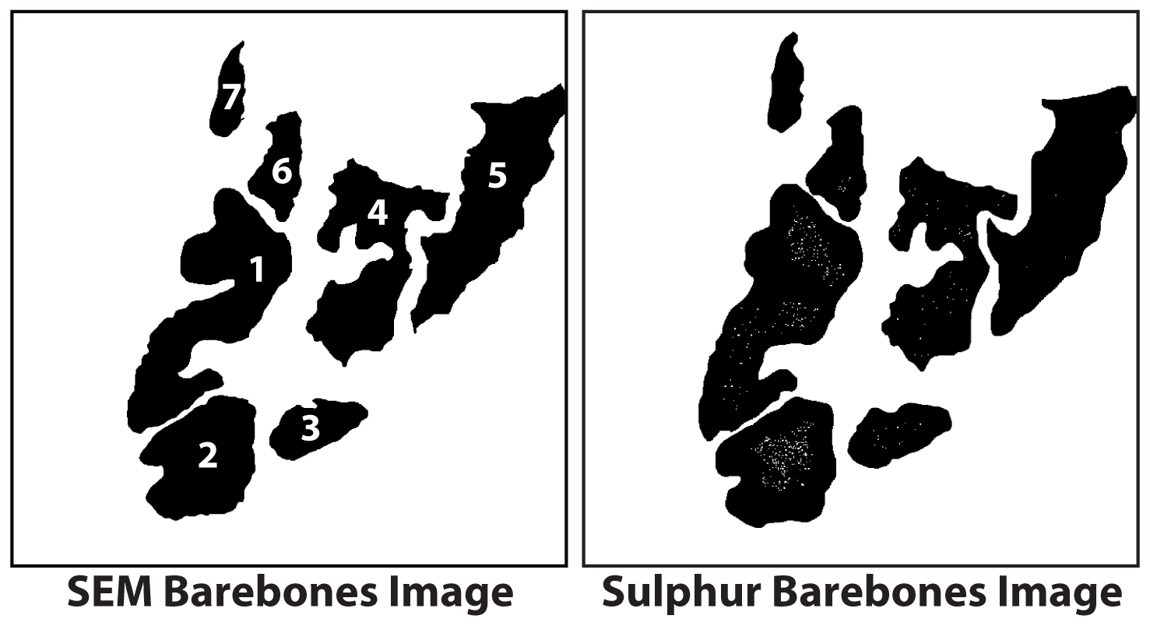

The subroutine will prompt you select the number of landmarks in the image/s that you would like to use, in the example above 7 landmarks have been chosen as shown. Select the total number of landmarks, so as to cover most of the region in the image. First open the rescaled MIMS SCALED image from subfolder (SCALED Sulphur map in this case). For each landmark, the Plugin will guide you to trace the feature very carefully and accurately. After you are done tracing and click ok, then the subroutine automatically sets the threshold to highlight the selected landmark only. If the threshold does not look right, then the user is given an option to set the threshold manually, by going to Image —> Adjust —> Threshold and then do manual adjustment. Repeat the procedure for the other landmarks. The images will be saved in a subfolder called “MIMS\_BarebonesXX” folder. Select the same landmarks and repeat the same procedure for the SEM SCALED image, which will save the output files in a subfolder “SEM\_BarebonesXX”. The “\_SCALED\_BAREBONES.tif” SEM and MIMS image, are shown above. The images look similar, but the Sulphur\_BAREBONES image seems to be stretched or bulged with respect to SEM\_BAREBONES image. The plugin UnwarpJ or any other Warp adjustment software should be able to correct for this.

NOTE: There is some kind of inherent bug in the ImageJ or Java image processing routines, which makes the thresholding work inaccurately if the brightness/contrast window of ImageJ is currently active, please close the window before clicking OK, the plugin will also prompt you to do the same.

**UnwarpJ :**

Purpose: This corrects for any nor-linear/warp distortions between two images. This Plugin is not developed by the authors. This Plugin is developed by Sorzano et.al and if you use MesoFusion in conjunction with UnwarpJ, we kindly request you cite both Krishna et.al and Sorzano et.al papers.

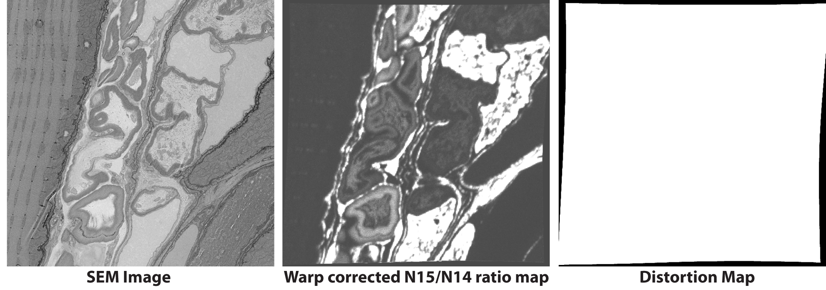

Now open the SEM and MIMS BAREBONES image (Sulphur BAREBONES image in this case), then go to Plugins —> Registration —> UnwarpJ. The authors of UnwarpJ also have another Plugin by the name “bUnwarpJ”, although it is similar in functionality, we recommend using UnwarpJ. The Plugin will throw up a window, in which you will have to choose which image will be “Target” and which will be the “Source”. The “Target” image is what you want to align to, so always SEM BAREBONES image (non-deformed) and the Source will be the MIMS BAREBONES image. Click “Advanced Options” - Initial Deformation should be Coarse (can use very coarse at times) and Final Deformation is Fine (never use Very fine), then select the “Save Transformation”, everything else is left to the default values, and then click Done. The “Save Transformation” saves all the transforms it performs into a text file, which can be loaded later and applied to any other image. The alignment may take a few minutes depending on size of image. Once it is done, it will prompt you to save transform txt file, please save this file. The plugin also throws up an image stack, with details of the macro and micro transforms in image form, it is not necessary to save this, but you can save it for future reference. Close all open images.

Final goal is to actually align the N15/N14 ratio map (the SCALED image) to the SEM image (also the SCALED); the steps above are only intermediate steps to facilitate the same. Open the SCALED N15/N14 ratio map (or the C13/C12 ratio map as the case maybe) and the SCALED SEM image. Then open the plugin UnwarpJ—> make sure source is SCALED N15/N14 ratio map and the target is the SCALED SEM image. On the UnwarpJ taskbar click on the icon that resembles a text file, it will open a l/O menu window choose —> load transformations —> select the transforms text file that you previously saved. Then wait for a few minutes for it to apply the transformations to the N15/N14 ratio map, DO NOT CLICK “DONE” at this step. Once it has finished applying the transforms, save the warped image. The warp corrected N15/N14 ratio map is shown above, and it is now completely aligned with the SEM image.

* 1. **Categorize ratio map :**

Purpose: This subroutine categorizes or divides the Warp corrected N15/N14 (or C13/C12) ratio map into a set of images based on their signal intensity. The signal intensity in a N15/N15 (or C13/C12) ratio map is directly proportional to the concentration of N15 in that pixel.

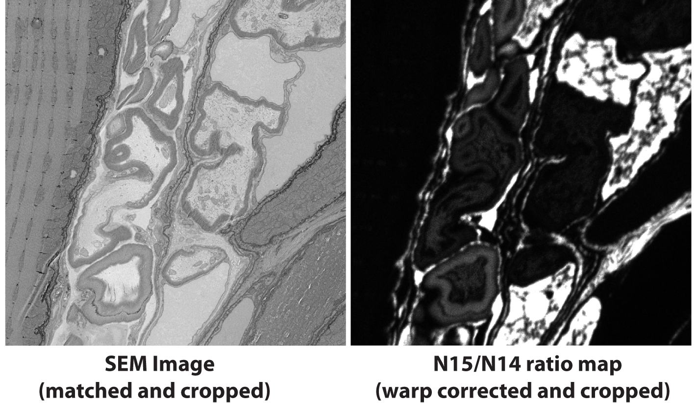

C:\Users\Ranjan\AppData\Local\Microsoft\Windows\INetCache\Content.Word\Categorize ratio map bottom.tif

The Plugin will ask you to open the warp corrected N15/N14 ratio map and the SEM image (SCALED image), then select a rectangular ROI to remove the discrepancies at the edges (like the one you use in the image shown in the UnwarpJ section of this document). The ROI will be then matched in the SEM image too, the unwanted regions will be cropped out both in the MIMS and SEM image as shown above.

The subroutine will then prompt the user to select the number of categories he wants the N15/N14 ratio map to be divided based on its intensity value. Generally, 4 categories should be sufficient, and the user will have to input the cutoff intensity values for each category. The different categorized images will then be saved in the subfolder called “FinalXX”. Each file name will start with the intensity value range selected for that particular image, so that it is very easy to identify.

It is recommended to choose the cutoff intensity values as multiples of naturally occurring isotope ratios. To elaborate further, the naturally occurring ratio of N15 to N14 in atmosphere is 0.364% or ~37 atoms of N15 for every 10000 atoms of N14. The N15/N14 ratio map that OpenMIMS computes, is inherently multiplied by 10000. That is, if the signal intensity of the N15/N14 ratio map at a particular pixel is 37, it means that this is equal to the naturally occurring N15 to N14 ratio i.e. it is background. If the signal intensity at a particular pixel is 370 for example, it means that this pixel has N15 concentration that is 10x the naturally occurring isotope ratio. In the example above, the intensity cutoff was chosen as (185 – 370), (370 – 1850), (1850-7400) and (7400 – Max) to represent (5x – 10x), (10x – 50x), (50x – 200x) and (200x – 750x) as shown in the figure above.

* 1. **Colorize ratio map :**

Purpose: This subroutine colorizes the different categorized MIMS ratio maps, and then overlays them over the SEM image. So the chemical information of interest is depicted while preserving the spatial resolution of the SEM image.

Open SEM image and the 4 categorized images (need not open the whole MIMS image i.e. the image that is saved as “XX\_FINAL\_FULL”). The plugin throws up an option, called histogram stretching, you can either turn it ON or OFF, depending on what works best for your set of images. For each of the categorized images choose the color code you will like to use.

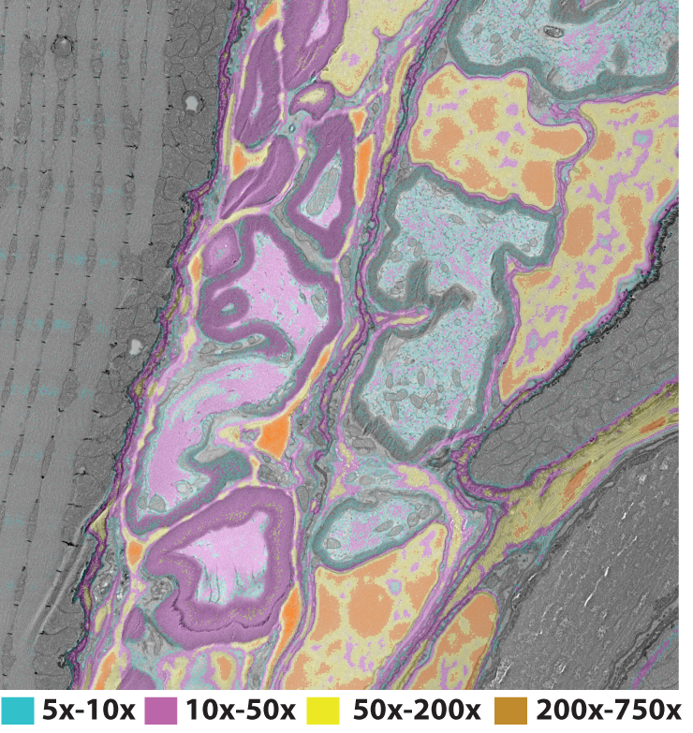

Recommended color codes are cyan, magenta, light yellow and vermillion, in increasing order of intensity. The color options should be chosen, so as to facilitate the people having color deficiency or blindness (Keene 2015) . For, the SEM image choose “Conventional” from the drop down. The intensity values for the images will be read by the subroutine from the file names directly, generally user will not need to change it. The plugin will output a color-coded ratio map overlaid on the conventional SEM image. Save this image.

**MESOFUSION Mosaic** :

The NanoSIMS image has limitations of scan raster, generally 256, 512 and 1024 pixels only. However, in the case of the SEM, in addition to having complete flexibility of raster size from 256 to 32,000 pixels, the ATLAS software can scan many large areas and stitch them together to create one large composite SEM image, typically encompassing several millimeters of sample. So, in such a scenario, it may be more practical to obtain many images (or tiles) of the OpenMIMS image, each of which is compensated for any non-linear distortions and then colorized to be overlaid over the composite SEM image to create a large colorized mosaic. The MESOFUSION Mosaic has additional subroutines built in, to enable this large scale mosaic.

The order of using the subroutines for processing of a large scale mosaic is :- **Rescale Resize Mosaic** 🡪 **Create Layout Mosaic** 🡪 **Categorize Ratio Map Mosaic** 🡪 **Colorize Ratio Map Mosaic** 🡪 **Assemble Tiles Mosaic**. The Plugins Create layout Mosaic, Categorize Ratio Map Mosaic and Colorize Ratio Map Mosaic work exactly similar to the Plugins of MESOFUSION Single. The Rescale Resize Mosaic has additional functionality added to detect and record the position/location of the individual MIMS tile images with respect to the large SEM composite image. And the last plugin of the pipeline Assemble Tile Mosaic, stitches all the individual warp corrected and colorized MIMS images into the large composite SEM image.

**ReScale and ReSize Mosaic**:

**Input Images**

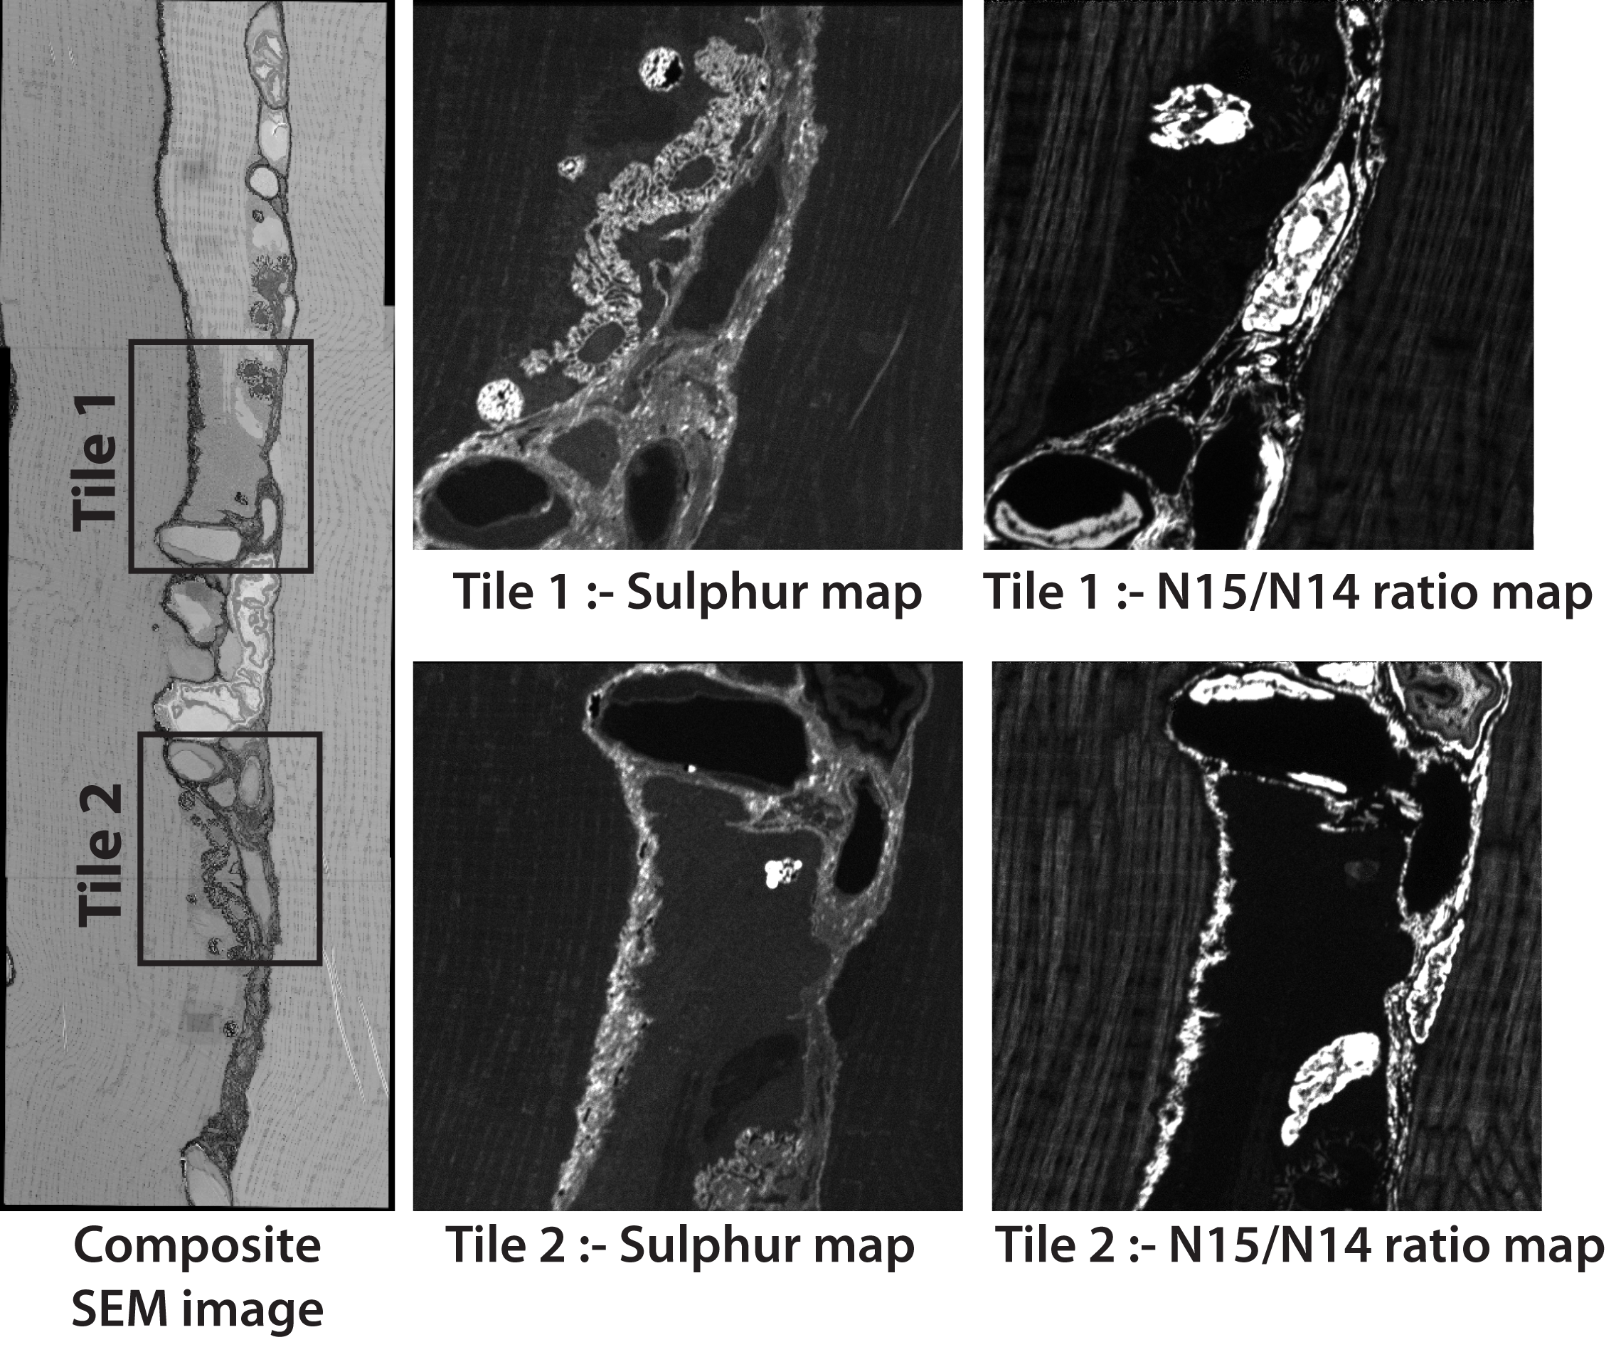

**Output Images**

**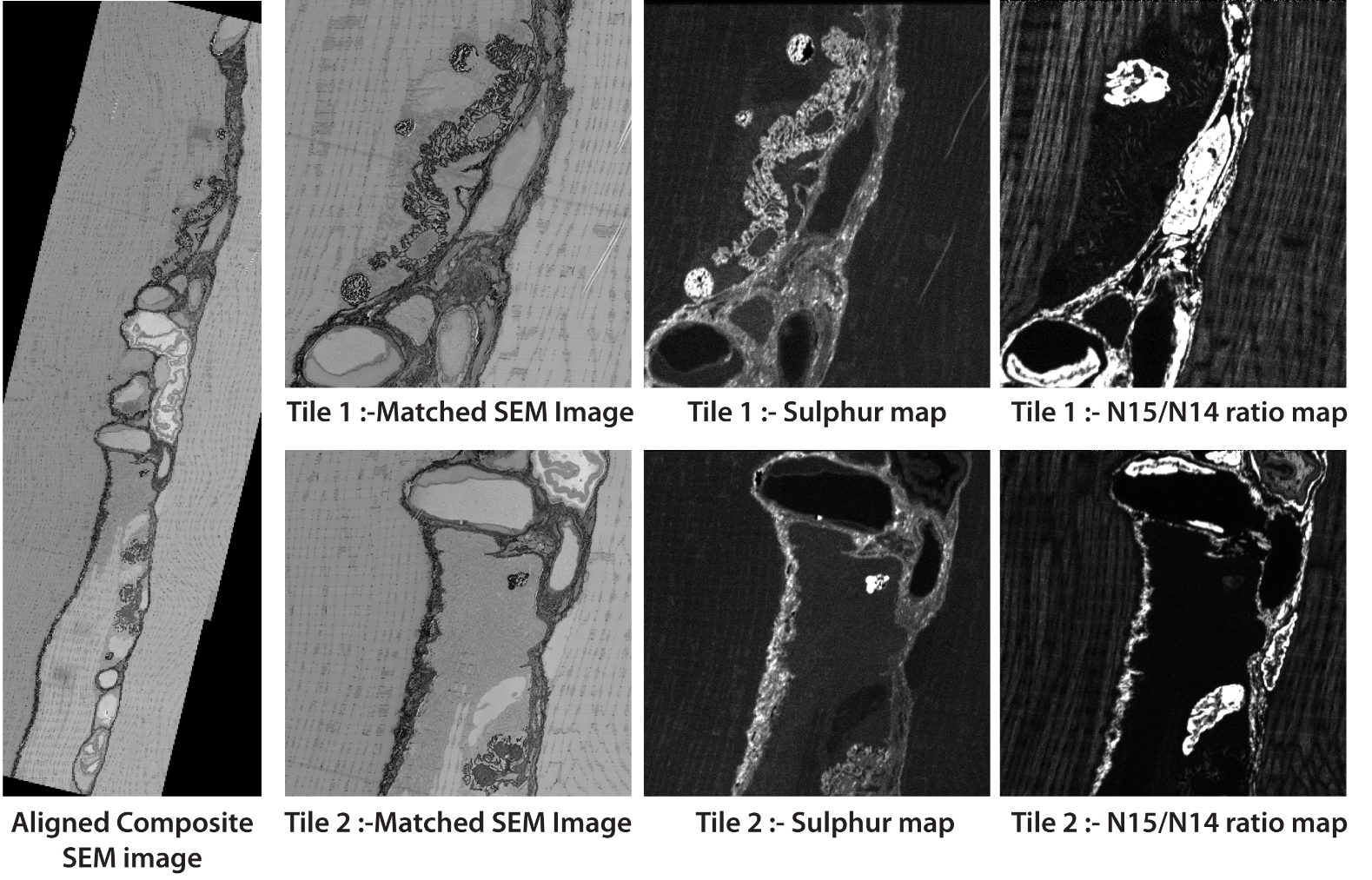**

The Plugin is designed similar to the one in MESOFUSION Single, in addition to prompting you to find out if you are using the N15/N14 ratio map or an intermediate image like sulpur or 14N map for the alignment, it also asks you how many tiles (or MIMS ROI scans) that you would like stitched into the SEM image mosaic.

The example below of myelinated axons near a neuromuscular junction, there are two tiles (or scan regions) that need to corrected for warp and then colorized according to the amount N15 present and finally stitched into the composite SEM image. The Plugin prompts the user to open the first Tile MIMS image (Suphur, N14/N15 …..map, the one you plan to use for alignment), in this case we use Sulphur map for alignment. The plugin prompts the user to select points in the Tile 1 MIMS image and the SEM image, to correct for global rotation and flip in the SEM image. Next, the plugin will ask you to select a rectangular ROI in the Tile 1 MIMS image enclosing a large organelle something like a nucleus, and then prompt you to select the same region in the SEM image. From this the software will be able to calculate the field-of-view of the SEM image that corresponds to the Tile 1 MIMS image. Finally, the Plugin will create a folder called “Tile 1”, and save the roughly aligned (not warp corrected) Tile 1 MIMS Sulphur, Tile 1 MIMS N15/N14 ratio map and the matching cropped SEM image.

The Plugin will then prompt you to open the Tile 2 MIMS image, and will go through similar sequence of steps to perform the rough alignment of the MIMS image with the corresponding SEM image. The Plugin will similarly create a second folder called “Tile 2”, and save the roughly aligned (not warp corrected) Tile2 MIMS Sulphur, Tile2 MIMS N15/N14 ratio map and the matching cropped SEM image. The Plugin will also save two “.roi” files that records the ROI on the SEM image for each of the tile. This .roi file will be used by the final **Assemble Tile Mosaic** plugin to stitch the colorized warp adjusted images into the composite SEM image.

**Create Layout Mosaic** 🡪 **Categorize Ratio Map Mosaic** 🡪 **Colorize Ratio Map Mosaic**

**Output Images after the running the 3 subroutines**

C:\Users\Ranjan\AppData\Local\Microsoft\Windows\INetCache\Content.Word\Colorize_Ratio_map_Mosaic.tif

You will have to go through these 3 subroutines exactly as you did for MESOFUSION Single, but now you will have to run these 3 subroutines separately for each of the tiles (or simply put the images in each of the “Tile” folder). The end result will be that for each of the “Tile” Folder will now have an aligned warp corrected colorized overlay image, as shown in the figure above.

**Assemble Tile Mosaic**:

This Plugin will then stitch these colorized tile images into the original aligned composite SEM image (i.e. the output image of the Rescale Resize Mosaic Subroutine).

**Output Image**

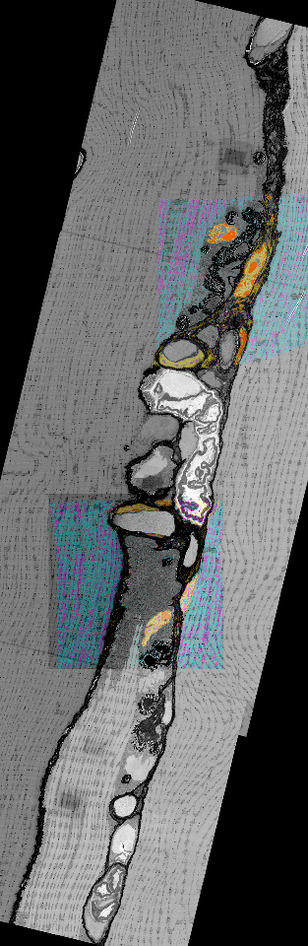

The Plugin will prompt the user to specify the number of tiles that need to be stitched, and then it will ask the user to open the aligned composite SEM image. Then the plugin will iteratively ask the user to open each of the colorized overlay tile image and its corresponding “.roi” file (output of Rescale Resize Mosaic), until it has gone through all the tiles. Finally, a stitched colorized Mosaic is outputted with the original SEM resolution as shown above, where the zoon features can be used to delve deeper into the regions of interest.

Any questions on this plugin should be addressed to [ranjan.ramachandra@gmail.com](mailto:ranjan.ramachandra@gmail.com) or raramachandra@ncmir.ucsd.edu

Benninghoven, A., et al. (1987). Secondary ion mass spectrometry : basic concepts, instrumental aspects, applications, and trends., Wiley.

Goldstein, J. I., et al. (2003). Scanning Electron Microscopy and Microanalysis, Springer.

Keene, D. R. (2015). "A Review of Color Blindness for Microscopists: Guidelines and Tools for Accommodating and Coping with Color Vision Deficiency." Microscopy and Microanalysis **21**(2): 279-289.

Schneider, C. A., et al. (2012). "NIH Image to ImageJ: 25 years of image analysis." Nature Methods **9**(7): 671-675.

Sorzano, C. O., et al. (2005). "Elastic registration of biological images using vector-spline regularization." IEEE Trans Biomed Eng **52**(4): 652-663.